BREAST CANCER CLASSIFICATION

**1.Introduction**:

**-Python:**

The Python programming language is an Open Source, cross-platform, high level, dynamic, interpreted  language.The Python 'philosophy' emphasises readability, clarity and simplicity, whilst maximising the power and expressiveness available to the programmer. The ultimate compliment to a Python programmer is not that his code is clever, but that it is elegant. For these reasons Python is an excellent 'first language', while still being a powerful tool in the hands of the seasoned and cynical programmer.

Python is a very flexible language. It is widely used for many different purposes. Typical uses include :

* Web application programming with frameworks like Zope, Django and Turbogears
* System administration tasks via simple scripts
* Desktop applications using GUI toolkits like Tkinter or wxPython (and recently Windows Forms and IronPython)
* Creating windows applications, using the Pywin32 extension for full windows integration and possibly Py2exe to create standalone programs
* Scientific research using packages like Scipy and Matplotlib

[Variables](http://www.voidspace.org.uk/python/articles/python_datatypes.shtml#variables)

* [Basic Variable Types](http://www.voidspace.org.uk/python/articles/python_datatypes.shtml#basic-variable-types)
  + [Numbers](http://www.voidspace.org.uk/python/articles/python_datatypes.shtml#numbers)
  + [Strings](http://www.voidspace.org.uk/python/articles/python_datatypes.shtml#strings)
  + [Other Useful Values](http://www.voidspace.org.uk/python/articles/python_datatypes.shtml#other-useful-values)
* [More Complex Data Types](http://www.voidspace.org.uk/python/articles/python_datatypes.shtml#more-complex-data-types)
  + [The List](http://www.voidspace.org.uk/python/articles/python_datatypes.shtml#the-list)
  + [Tuples](http://www.voidspace.org.uk/python/articles/python_datatypes.shtml#tuples)
  + [Dictionaries](http://www.voidspace.org.uk/python/articles/python_datatypes.shtml#dictionaries)
  + [Sets](http://www.voidspace.org.uk/python/articles/python_datatypes.shtml#sets)

**-Artificial intelligence:**

AI is the new buzzword of the 21st century. Artificial intelligence is coming in to our lives faster than we had anticipated. It’s helping us in shopping. It’s at the other end when you’re talking to customer service centre. It’s driving our cars and even recommending you videos on YouTube. It’s making sure that it knows about you more than you do.

Alan Turing defined AI as:*“Artificial Intelligence is the science of making machines do things that would require intelligence if done by man.”*That means, AI is not specifically related to computer science. This is a field of study that encompasses human behaviour, biology, psychology, and even language and linguistics. There’s still not a common consensus among academicians about its definition.In this blog post, we try to give a broader picture of AI. How it is organized and its various areas and fields of study. First we will discuss the terminologies associated with AI and then we will discuss the techniques used in implementing AI.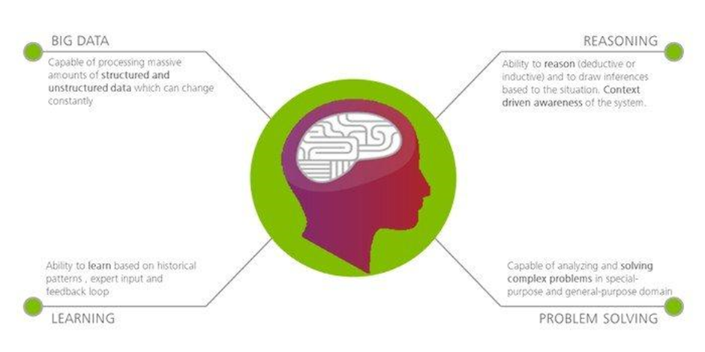

**Key AI terminologies**

1. Machine Learning

First thing to understand about machine learning is that it is an application of AI. It is the process by which we create systems that have ability to learn with experience.  
For instance, the systems which automatically identify spam emails are trained to do so by exposing them to millions of e-mails which are spammy and non-spammy in nature. With more data, the program is able to understand and learn what makes an email.Machine learning is different from a fully-AI system in the way that it does not know what it was trained to do. For instance, the above mentioned AI system can identify spams but it will

never be able to tell why it is doing that. Or if a new type of email comes in, it will fail to understand it.

2. Cognitive Analytics

As the name suggests, this field of study deals with the ‘thinking’ part of an AI. This system can not only analyse data to create obvious results, but it can train itself to deduce and synthesize new thoughts. For instance, if this system reads a Harry Potter book and is asked who were the two best friends of Harry, it can reply with Hermoine and Ron. To put it more clearly, this system can make sense of unstructured data.This system is being used a lot in chat bots and customer service platforms. Many recommender systems on the internet are using this type of systems to give custom content recommendation.

**3. Robotics**

Although a more general term that existed before the onset of the AI wave, robotics is getting a new push with the rise of AI. In the recent years, various companies have launched AI backed robotic systems. For example, MIT’s Cheetah II and IPsoft’s Amelia have taken AI based robotics to another level.Robotics, academically, is defined as a programmed machine that can perform rule-based tasks. With AI, the ‘rule-based’ part broadens as the robot learn with its experiences.

**Techniques Used in AI Myriads of AI techniques have emerged in the past decade for implementing and building AI systems.**

**Natural Language Processing**

In a one-liner, natural language processing is the study of how a computer interacts with a human language. Broadly, in application sense, it refers to speech recognition and speech synthesis in human language.This field of study is already in application phase and companies are using it in their voice assistants. Apple’s Siri, Google Assistant, Microsoft’s Cortana, and Amazon’s Alexa relies a lot on natural language processing.Natural language processing further uses different techniques for implementation like parsing techniques, text recognition, and part-of-speech tagging.

**Artificial Neural Networks**

Neural networks are available in living beings. Humans and animals uses a complex network of billions of neurons (which makes neural systems) to take decisions in day-to-day life and learn new things to do. Building artificial neural networks is an attempt to create neural networks modelled on our own brains!These networks can identify patterns in inputs as it processes a lot of data and learn from it. It uses different learning methods: supervised learning, unsupervised learning, and reinforced learning. Neural networks have wide applications in pattern recognition, machine learning, and deep learning.

**Convolutional Neural Networks (CNN)**

Convolutional Neural Networks (CNN) is one of the variants of neural networks used heavily in the field of Computer Vision. It derives its name from the type of hidden layers it consists of. The hidden layers of a CNN typically consist of convolutional layers, pooling layers, fully connected layers, and normalization layers. Here it simply means that instead of using the normal activation functions defined above, convolution and pooling functions are used as activation functions.

**Recurrent Neural Networks (RNN)**

Recurrent Neural Networks or RNN as they are called in short, are a very important variant of neural networks heavily used in Natural Language Processing. In a general neural network, an input is processed through a number of layers and an output is produced, with an assumption that two successive inputs are independent of each other.RNNs are called *recurrent* because they perform the same task for every element of a sequence, with the output being depended on the previous computations. Another way to think about RNNs is that they have a “memory” which captures information about what has been calculated so far. In theory, RNNs can make use of information in arbitrarily long sequences, but in practice, they are limited to looking back only a few steps.

**AI using python:**

Why Python for Artificial Intelligence & Machine Learning?

Whether a startup or an MNC, Python provides a huge list of benefits to all. The usage of Python is such that it cannot be limited to only one activity. Its growing popularity has allowed it to enter into some of the most popular and complex processes like Artificial Intelligence (AI), Machine Learning (ML), natural language processing, data science etc. The question is why Python is gaining such momentum in AI? And the answer lies below:

Less Code:

AI involves algorithms - a LOT of them. Python provides ease of testing -  one of the best among competitors. Python helps in easy writing and execution of codes. Python can implement the same logic with as much as 1/5th code as compared to other OOPs languages. Thanks to its interpreted approach which enables check as you code methodology.

Prebuilt Libraries:

Python has a lot of libraries for every need of your AI project. Few names include [Numpy](http://www.numpy.org/) for scientific computation, [Scipy](https://www.scipy.org/) for advanced computing and [Pybrain](http://pybrain.org/) for machine learning. [AIMA](https://pypi.python.org/pypi/aima/2015.2.8.5)- Python implementation of algorithms from Russell and Norvig's 'Artificial Intelligence: A Modern Approach' is one of the best library available for Artificial

Intelligence till today. Such a dedicated library saves developer’s time spent on coding base level items.

Support:

Python is a completely open source with a great community. There is a host of resources available which can get any developer up to speed in no time. Not to forget, there is a huge community of active coders willing to help programmers in every stage of developing cycle.

Platform Agnostic:

Python provides the flexibility to provide an API from an existing language which indeed provides extreme flexibility. It is also platform independent. With just a few changes in codes, you can get your app up and running in a new OS. This saves developers time in testing on different platforms and migrating code.

Flexibility:

Flexibility is one of the core advantages of Python. With the option to choose between OOPs approach and scripting, Python is suitable for every purpose. It works as a perfect backend and it also suitable for linking different data structures together. The option to check a majority of code in the IDE itself is also a big plus for developers who are struggling between different algorithms.

Popularity:

Python is winning the heart of millennials. Its ease of learning is attracting millennials to learn this language. Though AI Projects need a highly experienced programmer yet Python can smoothen the learning curve. It is practically more easy to look for Python developers than to hunt for LISP or Prolog programmers, particularly in some nations. Its extended libraries and active community with an ever developing and improving code have led it to be one of the hottest languages today.

**Introduction:**

* Early detection of cancers are essential for a rapid response and better chances of cure. Unfortunately, early detection of cancers are often difficult because the symptoms of the disease at the beginning are absent.
* Breast cancer is a cancer that develops from breast tissue.It is a malignant disease caused by an uncontrolled growth of cells in the breast.
* Breast cancer classification divides breast cancer into categories according to different schemes criteria and serving a different purpose. The major categories are the histopathological type, the grade of the tumor, the stage of the tumor, and the expression of proteins and genes.

**Symptoms:**

* A lump or mass in the breast.
* Swelling of all or part of the breast.
* Skin irritation or dimpling.
* The nipple or breast skin appears red, scaly, or thickened.
* Nipple discharge.

**Preventions:**

* Limit alcohol- The more alcohol you drink, the greater your risk of developing breast cancer.
* Don’t smoke- Evidence suggests a link between smoking and breast cancer risk, particularly in premenopausal women.
* Control your weight- Being overweight or obese increases the risk of breast cancer.
* Be physically active- Physical activity can help you maintain a healthy weight, which helps prevent breast cancer.
* Avoid exposure to radiation and environmental pollution

Methodology:

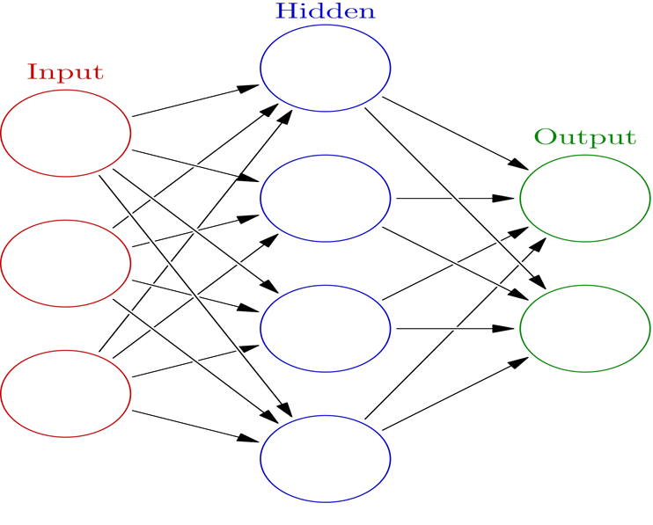

* An ANN is based on a collection of connected units or nodes called artificial neurons , which loosely model the neurons in a biological brain.
* Each connection, like the synapses in a biological brain, can transmit a signal from one artificial neuron to another.

**Future Scope:**

* For medical checking and reports will take a lots of time of patients as well doctor’s time too. So, it is time consuming process proceeding by pathology specified doctor and assistants, In thesis report this time spending process is done by just few mints and report will generate in short period of time then patients treatment will do further and faster.
* This software will use in pathology laboratories in short time will detect cancer in which stage after this doctor will suggest for further treatments.

**Conclusion:**

* An implementation of our new system to expose the cancer risk factors and to ensure that people are provided with the information and support they need to adopt in a healthy lifestyles.